**Module 9 – DB migration. Report**

**1. Liquibase**

2 tables – articles and authors:

After migration – column ‘name’ in table ‘authors’ was renamed to ‘fullname’:

Migrations list:

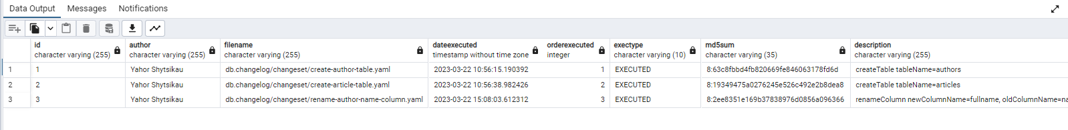

Migration of creating table was saved with tag ‘v1’.

‘Column rename’ rollback:

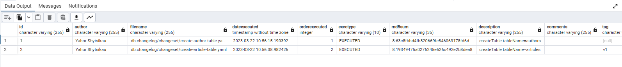

**2. Flyway**

For flyway two tables were created too, and two migrations were executed – first to create tables and second to rename column. I used community edition of FlyWay which doesn’t support ‘undo’ rollback operation. For rollback other migration was created:

